Ödev2.1 – Şaka Devresi – Erol Akif KURTCEBE

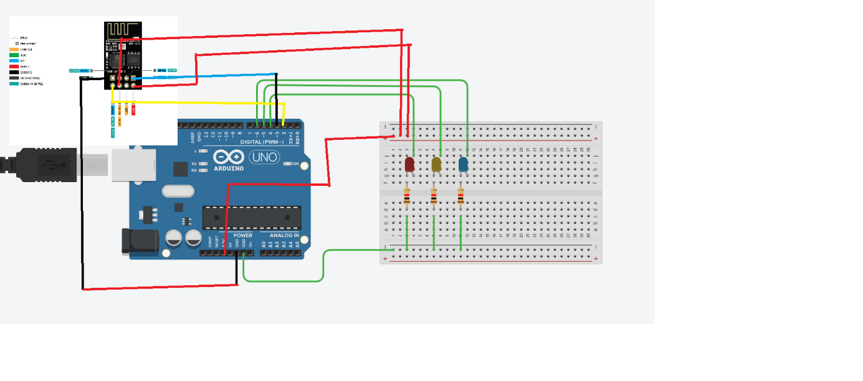

Kod:

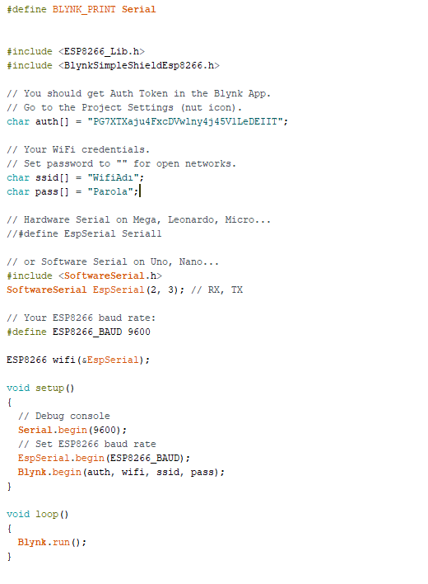

Uygulamalı video drive linki : <https://drive.google.com/drive/folders/1MEeOmWRl2-Eef5HFS_182BTcTgUI9BtJ?usp=sharing>